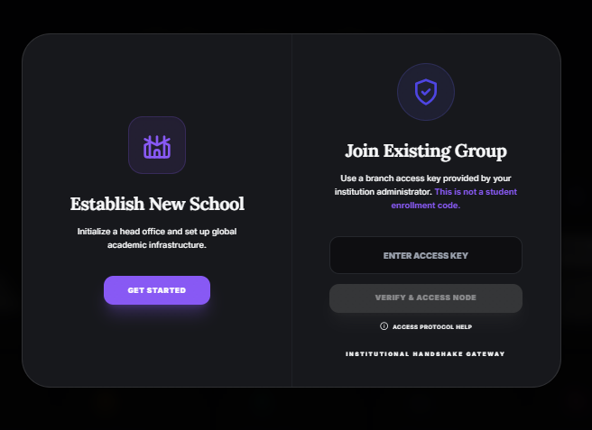

Please review the attached image and help define the user access rules and system behavior for the School Administration flow.
User Types & Access Rules
1. Establish New School
- User is a School Administrator
- Access type: Full access
- Capabilities:
  - Create a new school (Head Office)
  - Create and manage multiple branches
  - Expand the institutional network
  - Assign roles and permissions
  - Manage all branches and global settings
2. Join Existing Group
- User joins using Email + Unique Access Key
- Access type: Limited access
- Rules:
  - User cannot create or expand branches
  - User cannot select any branch manually
  - Branch access is automatically mapped
    - User email must match the Admin ID of a specific branch
    - User can access only that assigned branch
  - No access to global or head-office-level controls
  - Remove the Institutional Nodes from dashboard
  - limit data showing of Access level only respective branch details only not entire branch.
System Constraints
- Access key is unique and branch-specific
- Email verification is mandatory
- Permissions must be enforced at both:
  - UI level
  - Database / API level
SQl code:- -- FIX: Update verify_and_link_branch_admin to mark profile as completed
-- This ensures Branch Admins skip the "Create School" onboarding flow and go straight to the Dashboard.

CREATE OR REPLACE FUNCTION public.verify_and_link_branch_admin(p_invitation_code text)
RETURNS jsonb
LANGUAGE plpgsql
SECURITY DEFINER
AS $$
DECLARE
v_user_id uuid;
v_invitation record;
BEGIN
v_user_id := auth.uid();
IF v_user_id IS NULL THEN
RETURN jsonb_build_object('success', false, 'message', 'Not authenticated');
END IF;

-- Find valid invitation
SELECT * INTO v_invitation
FROM public.school_branch_invitations
WHERE code = p_invitation_code
AND expires_at > now()
AND is_revoked = false
AND redeemed_at IS NULL;

IF v_invitation IS NULL THEN
RETURN jsonb_build_object('success', false, 'message', 'Invalid or expired access key');
END IF;

-- Update Invitation
UPDATE public.school_branch_invitations
SET redeemed_at = now(),
redeemed_by = v_user_id
WHERE id = v_invitation.id;

-- Link user to branch AND Mark Profile Completed
UPDATE public.profiles
SET role = 'School Administration',
branch_id = v_invitation.branch_id,
profile_completed = true -- <--- CRITICAL FIX
WHERE id = v_user_id;

-- Update school_branches table
UPDATE public.school_branches
SET branch_admin_id = v_user_id
WHERE id = v_invitation.branch_id;

RETURN jsonb_build_object('success', true, 'branch_id', v_invitation.branch_id);
END;
$$;

